Whiteboarding:

* Pros
  + Lots of existing prep materials
  + Relatively inexpensive
  + Doesn’t require much time
* Cons:
  + Everyone hates it
  + Not realistic
  + Hard to assess objectively
  + Interviewers ask bad questions

Homework:

* Pros
  + More realistic
  + Get to use your tools/references
  + Can give problems that take longer than 45 min
* Cons
  + Hard for folks with caretaking responsibilities
  + Hard to help folks who misunderstand the question
  + Most homework questions take too long

Pairing

* Pros
  + Very realistic
  + Allows you to see if the candidate works well in a team
  + Much less prep for the interviewer
* Cons
  + Potential ethical issues with asking someone to do work without pay
  + Potential issues around non-competes and anti-moonlighting clauses
  + Intimidating for many people
  + Hard to pick a task that is consistent and fair

Better Questions:

* Keep it simple
* Write a function that takes input X, does Y, and returns Z
  + Ex: Write a function that takes in a string, checks if it’s a palindrome, and returns result as a boolean
* Easy is OK
* Avoid jargon
* Give example data
* Use a familiar context
  + Ex: Given a DNA sequence, find the most common sequence and return it
    - Show example data
    - Same problem: Write a function that determines the most common character in a string
* Problem contexts: sports, games, industry (finance, retail, etc.), math
* Ask your question out loud and in writing
* Don’t be overly specific
  + Don’t have a specific solution in mind
* Be Relevant:
* Don’t ask data structures and algos if it’s not relevant
* No brainteasers
* Encourage questions: if you have any questions about edge cases, feel free to ask
* Keep it short
  + 1hr max for whiteboard
  + 2-3hr max for a coding task
* Calculate tasks for buffer (3x what the task normally takes)

Better Evaluations

* Rubrics (rating guide for a categories)
* Ex: 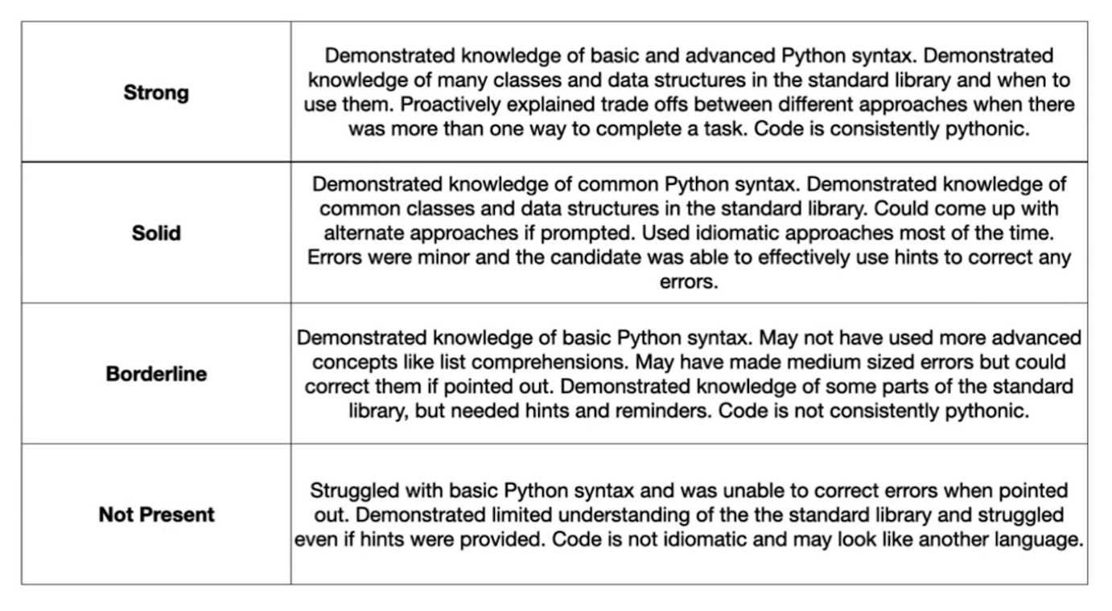
* Rubrics != points (it’s qualitative not quantitative)
* Question yourself (about how you rated)
  + Why not higher?
  + Why not lower?
* Can the candidate clearly explain technical decisions?
* Did the candidate consider common error and race conditions?
* How did the candidate handle hints/feedback?
* Does it matter?
  + Dinging for missed semicolon or something else minor
* Assume ramp up time
* Gender neutral pronouns (they/them)
  + “They performed the task very well”

Better Attitudes

* Positivity
* Team The Candidate
  + Be on the candidate’s team
* Be helpful
* Offer suggestions if they are on the wrong path
* Strengths focused
  + Don’t dwell on mistakes
* Accept “I don’t know”
  + If they don’t know, ask them how they would figure it out?
* Would they fit elsewhere?
* Some people need to eat, go to the bathroom, or pump (for babies)
* Don’t ask personal questions
  + Some innocent questions may make them feel bad (ex: Have you ready any books lately?)
  + Focus on questions about the job

